Absorption and Generation of Light
There are two basic mechanisms to generate light in general:
1.
2.

Semiconductor Emitters are an example of the second type.
In order to consider ths further let us consider two energy levels, E₁ and E₂.

Light can be emitted from this two level system when an electron falls from the upper level to lower on: As it does so the energy released by the fall is emitted by a photon where hν₂₁ = E₂ - E₁
Thus the number of electrons falling from E₂ to E₁ per unit time should be equal in this ideal system to the number of photons emitted per unit time.
Let us now consider the system in a bit more detail: We shall say that there are a total number of electrons per unit volume in our two level system of n_{T}. Similarly we shall define the number of electrons per unit volume in each of the two energy states as n₁ and n₂.
First let us consider what happens when we shine light on the system where the energy of the light is equal to hν₂₁ (= E₂ - E₁). If this is the case then we will expect the light to be absorbed, in the process electrons will be raised from E₁ to E₂. We can respresent this simplistically below.

From this we can now have an equation for the rate of change in the density of electrons in E₁ per unit time due to the light shining on the system:
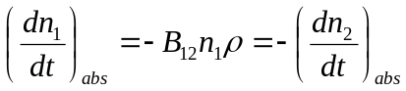 (1)
Where B₁₂ is a constant and 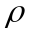 is the energy density of the light 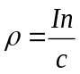(where n = refractive index, I = intensity and c is the speed of light.)
This will represent the rate of absoption of light in our system.
Once electrons are in the upper energy state, E₂ they can fall back to E₁ by one of two processes:
1. Spontaneous Emission 2. Stimulated Emission
Spontaneous Emission

In spontaneous emission electrons “randomly” fall down from the upper energy level to the lower one. It is important to note that there is no need for an external stimulation for the electron to fall down, it is simply a case that the electron is in a high energy state and after some time it will take the opportunity to fall down to the lower one.
As they fall so the electrons of course loses energy, which must be emitted, in our case as photons, as we described at the beginning of this lecture. The photon energy will be given by the energy difference between the levels: (hν₂₁ = E₂ - E₁)
Again there will be a rate at which the electrons fall and therefore a rate at which the upper energy level loses electrons. This is given by:
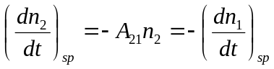 (2)
Where A₂₁ is a constant.
Stimulated Emission
Imagine the situation where the system is irradiated with lots of photons of energy hν₂₁ and there are a large number of electrons in the upper energy level, E₂, that is n₂ is large. In this situation a photon of energy E₂ - E₁ can interact with the electron in the upper energy state stimulating it to fall from E₂ to E₁. When this happens a second photon will be produced due to the electron energy loss. We can show this schematically:

A key feature is that this second photon will be identical to the one that stimulated the electron to fall in the first place. So what do I mean by identical. (What properties of the photon can we think of?)
1.
2.
3.
4.
Again we can write a rate equation for the transition:
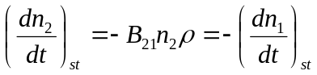 (3)
Note that this equation is the exact opposite to that for absortion [see equation (1)]
Now let us consider the system in equilibrium (≡^{m}). This means that no photons can be gained or lost, which in turn means that the number of carriers in each of the two energy levels remains the same. In such a case the rate of absorption equals the rate of emission. Hence, using equations (1)-(3) we get:
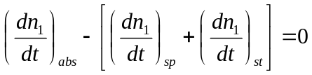 (4)
And substituting we obtain:
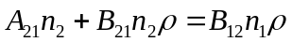 (5)
Equation (5) can also be rewritten as:
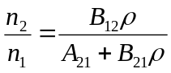 (6)
In thermal ≡^{m} we would normally expect the lower energy strate to have a higher density of electrons than the upper state. This is given by the Maxwell Boltzmann relationship:
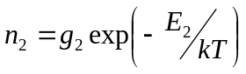, 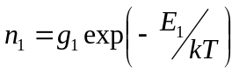
Which can be combined to give: 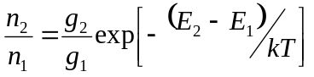 (7)
In these equations g₁, g₂ are basically a measure of the number of energy states per unit volume are available in each level. In this simple two level model we can assume g₁ = g₂.
Substituting (7) into (6) and rewriting gives 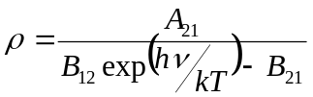 (8)
Let us now consider what a Black Body is:

For such a Black Body Planck predicted that 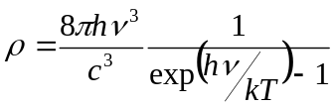 (9)
Equations (8) and (9) are equivalent if 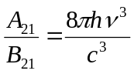and B₂₁=B₁₂ (as long as g₁ = g₂ also)
These conditions are the so called Einstein relations, and A and B are the Einstein Coefficients.
Looking at Equation (9) we can obtain the form of the Black Body radiation spectrum:

So what does all this tell us?
We we are aiming her to consider how we can make a laser. To obtain a laser we need strong stimulated emission. We want this as the properties of having a source continuously emitting a high density of photons with the same properties is advantageous in many applications.
Let us consider what we need to do to get Stimulated emission to be strong.
In this case we want: 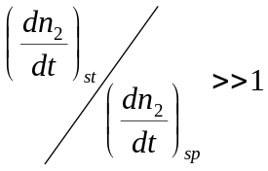, meaning that 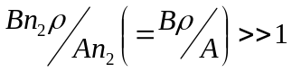
However using the Planck Relationship we have: 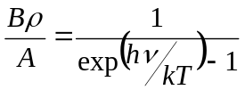
At Room Temperature (300 K) we have: kT/h = 3 x 10¹² s⁻¹.
However, visible light has a wavelength of around 500 nm, which equates to 6 x 10¹⁴ s⁻¹.
This means that 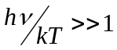 and hence 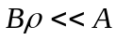
Hence at room temperature the stimulated emission rate is much less than the spontaneous emission rate.
This is as one should expect: Lamps, TVs, LEDs are all spontaneous emitting sources. To get stimulated emission we need to do something special!
How can we achieve this?
Looking at the equation above we can only control the energy density of the light, ρ. To change things we need to radically increase ρ until we can force Bρ>>A.
So the next question is how can we achieve that?

If we pump the system above hard enough then eventually we can achieve the situation where Bρ>A and stimulated emission will start.
At this point we have “Lasing” and the device is a LASER
L=
A=
S=
E=
R=
Usually in a real laser we can get the condition where Bρ>>A and as a result to the first order spontaneous emission can be ignored.

